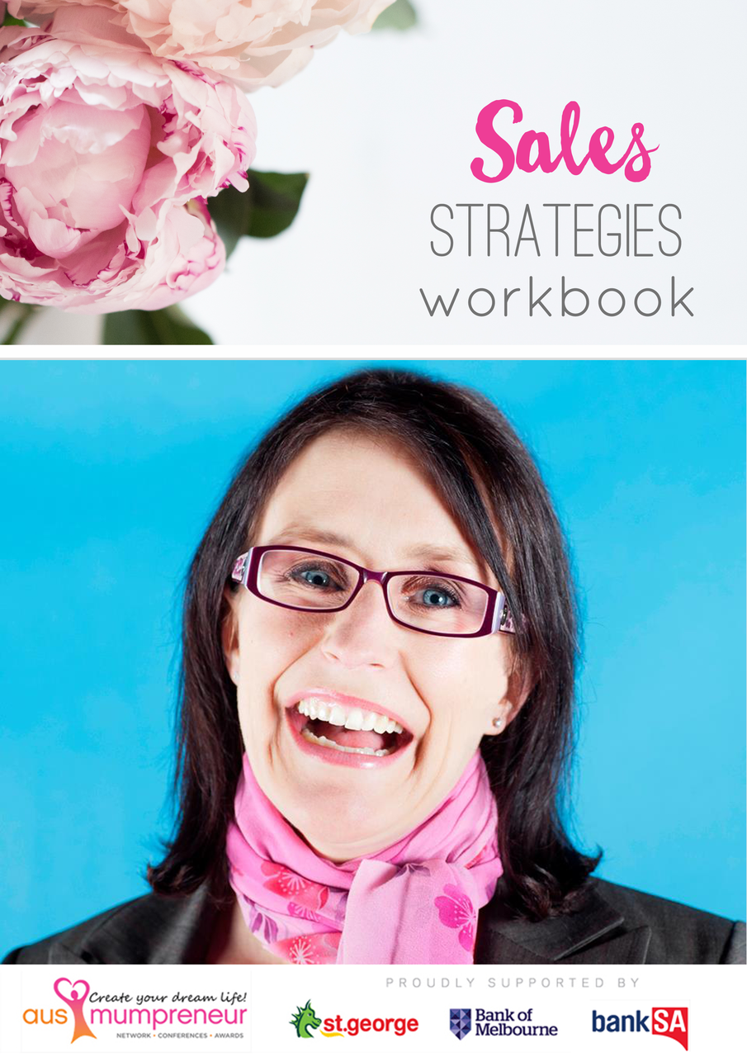

EXPECTATIONS:
This workbook is divided into 2 sections:
1. Activity questions
2. The Assessment
The activity questions are basic questions to consolidate your learning and come from the webinar you will have watched. The assessment is an extension of these and involves a little more work.
At the end of the assessment you will see a competency checklist that outlines the criteria you will be marked against. After you submit your assessment, our Women’s Business School Coordinator will take the time to go through and mark your assessment. Where further work or explanation is required, you will be sent an email asking you to provide some additional information. Where there is no additional work required, the assessment checklist will be returned to you completed with comments and feedback.
SUBMITTING ASSESSMENTS:
All activities and assessments must be submitted via email to kellie@thewomensbusinessschool.com (unless otherwise specified) no later than 5pm on the due date. In some extenuating circumstances, an extension may be granted with prior notice.
SATISFACTORY REQUIREMENTS:
Once your activities and assessment has been received, our Women’s Business School Co-ordinator will be responsible for marking. Please allow up to 2-3 weeks to receive feedback on your submitted work.
Where additional information might be required, the assessor will contact you directly where you may be guided to answer some additional questions to ensure you are clear on the course content and concepts discussed.

SALES ACTIVITIES:

- What qualities or traits do you think are necessary in order to be a good sales champion?

- Sometimes we don’t even realise we’re using sales tools in everyday life. Think about a situation in your family or social life where you’ve had to ‘sell’ an idea or convince someone of something. Explain the situation and what you said/did to get your point across.

- Part of being a good sales person is being honest. In a couple of sentences, tell us why you believe in your product or service?

- Listening skills are vital in ensuring you not only know what your customer is after but you also know the best way of pitching your product or service to them. Thinking about your business, what are 4 questions you can ask your customer in order to gather some meaningful information that you can use in selling them your product or service?

- Name the 4 parts of our body we use to listen effectively to our customer or clients and explain the importance of each.

SALES ASSESSMENT:

The following assessment activity is aimed at trying to get you thinking like a sales champion. When you interact with customers you need to do so with belief and conviction in your business.

Moving forward we hope you can use the elements presented in this assessment as useful tools in your business.

PART A:
Remember, selling is all about ‘setting the scene’. In this assessment activity set the scene for your business (or business idea).

Answer the following questions in relation to your product or service. In the case where you have multiple products or service offerings, use 1 as an example but know you can then apply this method to anything else you sell.

Your product or service is:

What is your product/service’s intended use?

What are some benefits or features of the product/service?

How can my product/service help my customer?

What is the price of my product/service?

What’s the reasoning around why my product or service is this price point?

PART B
Using the information above, create a sales pitch ‘script’ that you could use on a customer that walks into your store or office and enquires about your product/service you sell. In the situation where you are an online store or don’t have a face to face client base, script a phone conversation with a customer or a ‘sales’ blurb you could use on your website explaining one of your products.

*Tip: be detailed, leave no stone unturned. Ask all the questions you expect a customer to ask you and remember the tools you’ve learnt in this Sales webinar to effectively ‘set the scene’ as well as what you’ve learnt about creating sales champions (listen, actively look for objections, Find Fit and Create Value)

PART C
An important part of the sales process is all around ‘creating value’ for the customer. Thinking about this, what could your response be to the customer who objects with the following:

Objection 1: It’s a bit too expensive

Objection 2: I don’t think I really need it

Objection 3: I’ll have a think about it and let you know

PART D
MILESTONE REFLECTION
What was your milestone for this month?

Have you reached it?

