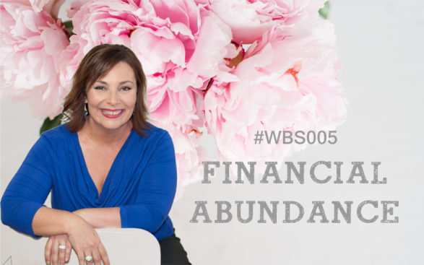
EXPECTATIONS:
This workbook is divided into 2 sections:
1. Activity questions
2. The Assessment
The activity questions are basic questions to consolidate your learning and come from the video lesson you will have watched. The assessment is an extension of these and involves a little more work.
At the end of the assessment you will see a competency checklist that outlines the criteria you will be marked against. After you submit your assessment, your assessment will be marked. Where further work or explanation is required, you will be sent an email asking you to provide some additional information. Where there is no additional work required, the assessment checklist will be returned to you completed with comments.
ASSESSMENT DUE DATES:
All assessment due dates are in The Women’s Business School Calendar that has been emailed to each student. In addition, the due date can also be found in the online portal at the introduction of each topic.
SUBMITTING ASSESSMENTS:
All activities and assessments must be submitted via email to Kellie@thewomensbusinessschool.com (unless otherwise specified) no later than 5pm on the due date. In some extenuating circumstances, an extension may be granted with prior notice.
SATISFACTORY REQUIREMENTS:
Once your activities and assessment has been received please allow up to 4 weeks to receive feedback on your submitted work.

FINANCIAL ABUNDANCE
ACTIVITIES

1a. What are the top 3 reasons that women in business don’t make money?

1b. Do any of the above reasons currently resonate with you? If so, outline which one and what you think you need to do to turn this around.
2. Make a list of all the costs you currently have in operating your business. We’ll use this list later in the assessment when we look more closely at your fixed costs.

3. What is a ‘peace of mind’ account and what are the benefits of having one?

4a. As Michelle discussed in her video, it’s important to have a system in place for invoices or as she likes to call them, “Blessings already received”. How do you currently do this in your business?

4b. Is there anything you think you need to change to streamline your current process?

5. What are the advantages of keeping your business and personal expenses separate?

6. What is the difference between ‘Cash Flow’ and ‘Budget (or Money Plan)’?

7a. What activities should we be monitoring on a weekly basis?

7b. What activities should we be monitoring on a monthly basis?

KNOWING YOUR NUMBERS
ASSESSMENT

Getting our finances into order is a big part of running a successful business. In our Knowing Your Numbers Webinar, Michelle spoke about the 3 practical areas of knowing your numbers:
Money Going Out
Money Coming In
Monitor and Measure

In our assessment for this topic we’ll focus an activity on each of these areas to assist you in consolidating the information and making it practical for you and your business!

In her webinar, Michelle spoke about you completing these activities to give you a better understanding of your finances.

PART A – MONEY GOING OUT
Our fixed costs (costs to operate) are essential to know. What’s it costing you to make a sale? In Assessment Part A we’re going to look at this in a lot more detail.

In activity question 2, you wrote a list of your fixed costs. We’re now going to build on that information by adding the actual costs themselves so you can work out your annual, weekly and hourly rates.

DESCRIPTION | $ COST (ANNUAL)

What is your total annual figure?
What is your weekly figure?
What is your hourly cost to operate?

REFLECTION: Write a paragraph explaining your thoughts/feelings on seeing the hourly cost to operate figure. Is it what you were expecting? How do you feel as a result of conducting this exercise? Are there things you could change to reduce these expenses?

PART B – MONEY COMING IN
OK, so you’ve now had the opportunity to look at the money going out and what your cost to operate is. We now move forward and start to look at the money coming into your business and how you keep track of this!

Stemming from the activity you did previously where you worked out your fixed hourly rate, we now want to work out how much money you would like to make for yourself.

- What is your ideal hourly rate?
- What is your ideal weekly wage?
- What is your ideal total annual wage?

Add together your Fixed Cost Annual Rate (from Assessment Part A) to your Total Ideal Annual Wage =

This is the total amount your business will need to sell each year to cover all expenses plus your ideal income.

- How many of your products or services would you need to sell to reach this amount?

- After looking at the figure above, outline your thoughts, opinions, ideas about what you envisage for your business in the next 12 months.

- How you can achieve this amount?

PART C – PLANNING FOR GROWTH

1. How much would you like to invest back into the business each month?

2. What upcoming projects do you need to budget for in the next 12 months? How much will each cost approx?
1.
2.
3.

4. How much would you like to spend on professional development this year?

5. Add these amounts to your total annual expenses. How much extra do you need to make each year to grow your business?
What’s your strategy to create this extra income in your business?

PART D – MONITOR AND MEASURE
- A vital part of keeping control of your finances is ensuring you consistently look over your invoices and figures to ensure you’re on track for success. Let’s look at scheduling your ‘money time’ weekly and monthly.

WEEKLY ‘MONEY TIME’ SCHEDULE
What day of the week will you do it?
Where will you do it?
Who will be involved?
What specific money tasks will you look at? .

MONTHLY ‘MONEY TIME’ SCHEDULE

What day of the week will you do it?
Where will you do it?
Who will be involved?
What specific money tasks will you look at?

- Reflection: As a result of this lesson, what are 2 things you feel you need to adapt or change with your business moving forward when it comes to finances? Talk though each and provide a summary of why you’ve chosen that task and what you will do differently.

ASSESSMENT ACTIVITY CHECKLIST: KNOWING YOUR NUMBERS
Student Name:
PART A |  | COMMENTS
- Activity executed correctly showing the student has a good understanding of the requirements.
- Fixed costs listed are reasonable and all encompassing
- Annualised figures are reasonable and in line with student’s business
- Thorough reflection completed and answers all questions asked.
PART B
- Activity executed correctly showing the student has a good understanding of the requirements.
- Good explanation and thought process for creating a profitable business. Logical improvement suggestions made.
- Student has reflected on the activity with detailed analysis of findings.
PART C
- Activity executed correctly showing the student has a good understanding of the requirements.
- Good explanation and thought process for planning for growth. Logical improvement suggestions made.
PART D
- Activity executed correctly showing the student has a good understanding of the requirements.
- Money Time Schedule completed correctly.
- Student reflection outlines 2 improvement opportunities and shares ideas around new ideas or suggestions for the improvement.

Overall Comments:

Marked by: DATE:

