THE WOMEN’S BUSINESS SCHOOL
#WBS004
IGNITE PROGRAM
DIGITAL STRATEGY

NAME:

Social Media Strategy
Social Media Marketing is a wonderful way to amplify who and what we are in person out to the world. When we understand the Social Selling tools available we can not only amplify our message we can connect, learn, and engage with our ideal customers to grow our business.

Where do we start?
With 2.7 Billion users and the most sophisticated advertising platform, it makes sense to start with Facebook first. Once the basics are established here, the learning can be applied to other platforms.

The key here is learning. There is no one size fits all marketing plan. However, there are key principles that apply to all businesses and when these are applied you gain learning applicable to your business. Regularly reviewing these learnings in context of your business goals enable you to refine what you are doing, know what is working and then amplify what is working.

The GCT approach
Goals, Content and Targeting are the 3 elements that work together. If one of these is not defined or working, the campaign will not reach its potential.

This approach maximises organic visibility and connection opportunities and minimises advertising spend.

Facebook Ads Manager is set up in 3 phases. Awareness, Consideration (aka Engagement) and Conversion. At each phase of the sales process it is important to be clear of what we are trying to achieve. Defining the Goal, who is the target audience and what content will connect them is critical.
At each of the 3 phases the goal and audience changes

For example:
- Budget $30
- Goal ‘Create a new warm audience (size 1,000) of people interested in why our business is established @ 3 cents per 10 second view.’
- Target Audience New Mums, who have never heard of product.

To obtain the goal, the target audience needs to be connected to the goal via the content for the ad.

Content can and will change depending on the Goal and the target audience.

If you do not have one of these 3 components, Goals Content, Targeting (GCT), you will not be able to diagnose what is working or not.
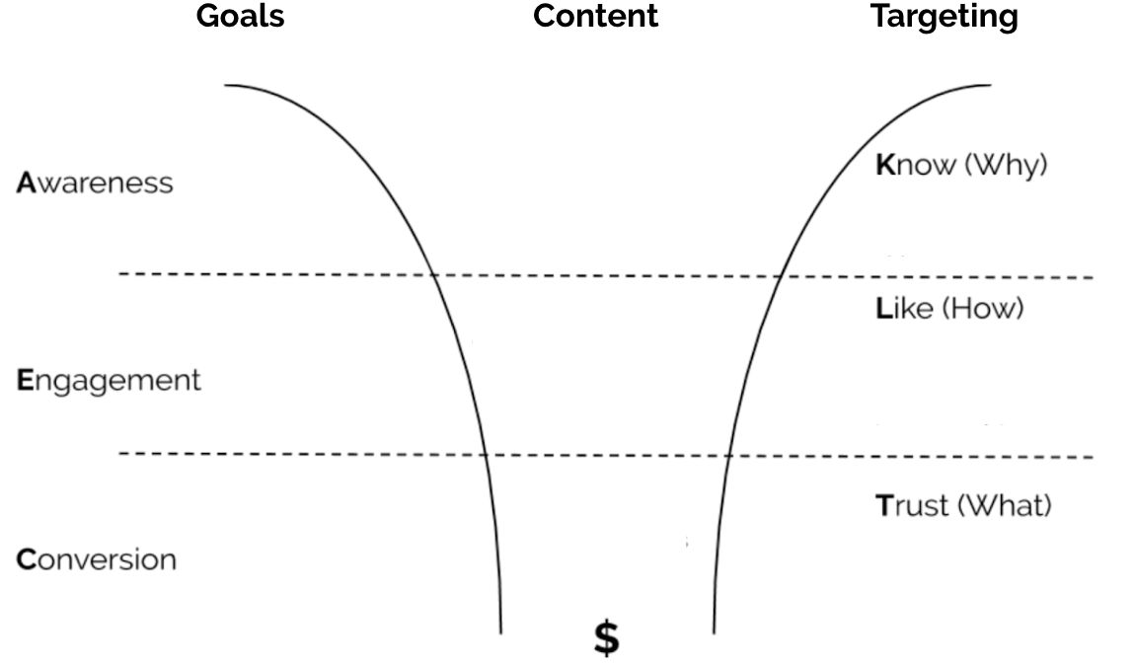
The GCT approach can be applied to every piece of content you create for any marketing activity.

Will One Ad Convert?
It takes an average of 12-15 times for someone to be in contact with your brand before they purchase. This jump in number of touch points is largely due to the event of digital technology. People like to ‘just Google it’, they search Facebook, follow hashtags on Instagram and despite technology they still love to discover things in person too by going to expos, markets and chatting to their friends over coffee, tea or at BBQ. Marketers are also consistently looking for ways to interrupt the day of their ideal customers leading to a consistent bombardment with advertising collateral. The reality is the culmination of technology and saturation of advertising, it is harder to breakthrough. This means it usually takes longer to make an impact and obtain a sale. This process can change when we as marketers and business owners focus on connection rather than selling.

People don’t buy what you do, they buy why you do it.

This is why brands like Nike, Apple and Coke share ads that are in line with lifestyle and their key message. When you buy their product you are buying their values. If they only advertised their product, without the context and what they represent, the emotional connection would not be there.

People will connect with you when they know how much you care.

Start with recording your WHY

There are many types of content we can review, for this module for we are focusing on video.

A key ‘Hero’ video all businesses should create is a WHY video. This is a perfect start to start practising video and an opportunity to share the moment that compelled you to create your business.

The format for a WHY video includes 4 key components:
  - No ‘BUMPER’, that is no introduction, start story straight away
  - Start with, When I was… this is a story of a specific moment that emotionally compelled you to start your business.
  - I believe… this is a belief statement that is bigger than you, it’s how you contribute to the world.
  - I started… this is where you introduce yourself at the end.

Think of the last movie that made you cry.
When you can connect your story to your business product or service it is powerful.
Recording your origin story is a great start.

Videos enable stronger emotional connection and also enables great insights that can be used to refine target audiences and achieve business goals.

Measure of Success

Tracking
The end goal is to ensure that you can remarket to a warm audience. Having a Facebook pixel installed is key. I recommend using Google Tag Manager as this is one ‘home’ for all your 3rd party tracking. Too much 3rd party tracking weighs your website down and impacts SEO.
If you don’t have tracking in place yet, start with installing a Facebook Pixel and Google Analytics on your website. Depending on your website platform will depend on how this implemented. Refer to your website platform for instructions on this.

What Standards of Excellence Look Like
A view of a video on Facebook is constituted as 3 seconds. Average view time of a video is 6 seconds. We are looking for above average markers of success.

Metrics to use:
10 second views
>50% of views are 10 seconds or more

10 seconds demonstrates that someone has gone beyond to engage with your video. They may not have clicked at this point, but they have definitely stopped scrolling and started watching. This passive engagement has registered with Facebook and is being tracked. As a benchmark, greater than 50% of total views being for 10 seconds or more indicates the content is resonating with the target audience.

ASSESSMENT TASK #1

Create your Goals Content and Targeting (GCT)

- Set your Cost Per Acquisition (CPA)
CPA is calculated by:
Dollar Value of Marketing Spend = CPA
No. of Sales
For example:
$10,000 = $20
500

If you have not made sales yet, this formula can be used to forecast and adjust expectations based on the projected sales you would like. Substitute Dollar Value of Marketing Spend for Marketing Budget and No. of Sales can be substituted for No. of forecasted sales.

- Based on your circumstances what is your CPA?
- Define your Target Audience.
  - Who are they?
  - How old?
  - Gender.
  - Where do they live?
  - Who do they live with?
  - What is their occupation
  - What do they do for fun
  - How much money do they earn?
  - What do they like to spend money on?
- Create your Content
  - Create a WHY Video
  - Publish the WHY video with captions.
  - After 24 hours check the video insights - What are the total views?
  - How many 10 second views?
  - Does the video hit the Standards of Excellence?
  - What have you learned about creating videos?

Observe & Measure:
Boost a post that has hit the Standards of Excellence (SAE) for $7 a day over 7 days campaign.

- Describe the Audience you boosted this video to.
- Why did you select this audience?
- How many likes did the post receive?
- How many comments did the post receive?
- How many shares did the post receive?
- Did the post receive any negative feedback?
- After 7 days does the post retain the Standards of Excellence?
- Do you view this campaign as successful? Why/ Why not?
- Reflect on what you learned from this exercise. What would you do differently next time?

ASSESSMENT TASK #2 Blog Writing

Blog writing requires the same approach as creating videos or images. Content needs to be created with your goal and target audience in mind.

Blog writing is another form of Content Marketing. The benefit of doing blog writing is the ability for those interested in your products or services to read about what you are offering. One of the key people reading your blogs are search engines, primarily Google.

Google also reads your blog posts and combined what they read, and other information on your site this impacts your ranking in search results.

It is important to note though if you only write for search engines stuffing in keywords, you miss opportunities to connect with your target audience and ultimately growing your business.

Below are the essential principles of creating blog posts. Accompanying the assessment is also a checklist with further details on how to optimise your blog posts. Think of the checklist as an opportunity to turn a good meal (meat and 3 veg) into a great meal. Both serve a purpose, however when you use the attached checklist you have the opportunity to create a wow factor that will increase your chances of standing out, being more memorable and organically being found online.

How Often?
Quality is more important than quantity. Due to the saturation of content being pumped into the online ecosystem, a blog post of 700 to 1,200 words once a month is better than trying to write daily or weekly. Planning and allocating time for this each month can be a great catalyst to gain online visibility. Depending on your balance of work priorities, allow yourself 1-2 hours per week over a month to create and publish the blog post.

What do I write about?
It comes down to one thing. Your target audience.

Focus on what interests them. Start with the problem your product or service solves for your target audience. The more you can talk about this in the language and terms they understand, use and search for, the increased likelihood of you appearing in search results when they search AND also resonating with your target audience when they read your blog post.

The ultimate in any content, including blogs is that the content connects them. It is a win-win when your product solves their problem, they are searching for it and they find your content, comment and share it.

You help this process along by initiating the discovery of the content via sharing through your Social Media and other available networks (e.g. Email Newsletter).

One of the simplest and easiest ways to find what search terms people searching related to your product or service is to start typing into Google a word related to your business e.g. ‘Personal…’ you will see Google start to populate a list of terms these pop up in relation to the most searched terms. Keep typing words to get more specific e.g. ‘Personal Stylist…’

Refer to the checklist supplied for additional ways to generate ideas for blog posts.

Choosing a title
Once you have your topic, you need to create a title that’s going to catch attention and resonate with your ideal clients (customers). Ideally use the keywords that you are basing the topic idea on in the title. For SEO best practice limit the title to 70 Characters including spaces. E.g. 3 Reasons Why A Personal Stylist Is Good For You
Outline the topic
Keep it simple. Once you have your idea, write 2 -3 paragraphs about it. Then look to add body to it by adding analogies. Where possible analogies from personal experience or your customer’s experience help make your content unique. Being unique will help you stand out and be memorable with new clients. These analogies help to give understanding and build confidence and trust in what you are sharing.
Find 2 -3 pictures to help get the message across too. Adding ALT text to each image will also help you to be ranked and found on Google and other search engines. For ALT text I recommend using the title of the blog post with a couple of keywords that describe the image e.g. 3 Reasons Why A Personal Stylist Is Good For You - Personal Stylist Sydney
Do you add a Call To Action?
The next step is ensuring you have a compelling offer or call to action. Being clear on what you want to achieve with your blog post will help on what type of call to action to add.
Why do you want people to visit your site? It’s normally so that they’ll buy something. How can you entice them into buying from you? You could offer a package of different products together. You could feature a popular or new product. Be careful if you are discounting as you do not want to lose money on the offer. Where possible consider adding value instead.
Or maybe your objective is to get people to sign up for your newsletter or as leads so you can ring them, you could run a competition or prize giveaway or you could create a free download of some kind.
Your offer normally goes at the end of the post. Put a time limit on it and create a sense of urgency and encourage them to take action right now rather than later on when they might miss out and include a link through to the sales page.
Promote
The most important step of all is to tell people about your content! Share it to facebook, pinterest, twitter, instagram, linkedin and put it in your newsletter too. Use interesting images and include an excerpt of your text to get people interested rather than the whole post and entice them to go to your site to READ MORE >>.
Let's get started!
Part A/
Answer these three questions:
- Who is my audience and what are they interested in?
- Is this information relevant to my business and products or services?
- What are people who want what I’ve got searching for on google?

Part B/
Choosing a title and outline the topic
Brainstorm 4 titles and the topics for blogs you could write
1
2
3
4

Part C/
Call to Action:
What will you offer to turn your readers into customers it could be a printable, special offer, competition etc, get creative

Part D/
Promote:
How will you promote this content?

SUBMIT your Assessment:
- WRITE one blog post from the topics you have outlined above here
- Don’t forget to include a call to action and the images you would use
- Explain why you chose the image, content and call to action or offer for this blog post.
- Explain the ideal customer targeting you thought about when writing the content for this post
PART 2. ADVANCED*
*Optional activity
Publish your blog post on your website and then promote on social media. Now write a 400 – 600 word reflection on your results. Submit together with a screenshot of your social media posts promoting your blog and a link to your published blog post.
1. Observe & measure:
- What were you hoping to achieve with your blog post? Share your Goal (Awareness, Engagement or Conversion) and Target Audience (Warm Audience or Cold Audience).
- Based on the Goal you defined review and share the following:
  - Followers - how many facebook or instagram fans before you started compared to at the end,
  - Engagement - how many likes or comments the post attracted
  - Hits - how many click-throughs to your website happened
  - Leads – how many new inquiries were generated
  - Sales - how many sales were generated
  - Any other things you noticed
- Reflect on what you learnt from this campaign and ideas for what you would do differently next time.
PART E
Milestone reflection
1. What was your focus milestone for this month?

2. Have you reached this milestone?

3. If you have, well done!! If you haven’t reached it, reflect on why not, what happened and what you need to do next to be able reach it.

