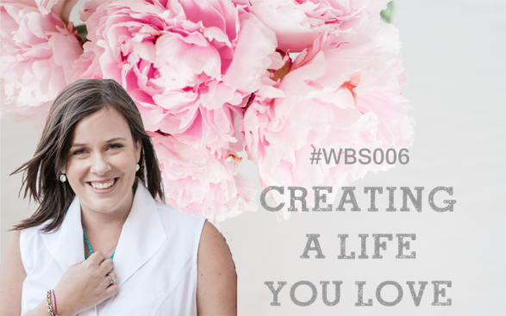

Susan believes that “A great life will create a great business” and in this module we’re going to focus on the steps to help get you on the path for creating both!
Think about a time when something amazing happened in your life and you were feeling great, then miraculously something even better happened next! Has this happened for you? Susan believes that “joy is a pre-condition for success in business” and that if we can focus on bringing more joy into our life we will attract more success to our life as well.
Susan’s personal formula for success is:
The triple bottom line
- JOY
- PURPOSE
- PROFIT
Her joy experiment was all about doing only the things that brought ‘joy’. If she’s in a meeting with someone and she’s not enjoying it, she will now leave the meeting instead of staying as she used to (and as most people would!). She now focuses on ‘what matters most’ and creates boundaries around her time so that she can focus on the projects and work that bring the most joy to her. She also says NO instead of always saying yes and is a master ‘single-tasker’ she lives a life of being more, by doing less!
Science proves that “when you are feeling joyful or happy you have access to 80 more of your brain’s resources.” This then creates more space for creativity and ideas.

PART A
1. How can we bring more JOY into our lives?
List 7 things that bring you joy | List 7 things in your life that suck joy

2. REFLECTION: What can you do to reduce the things that suck the joy from your life? What can you do to get more of the things that bring the joy into your life?

3. What really matters?
Have an honest look at what matters in your life and where you would like to make changes.
For the below table list 3 things in each row:
Write in specific detail the 3 things that matter most in your life and why they matter so much to you | Be honest – Which 3 things in your life get the most of your attention?
1. | 1.
2. | 2.
3. | 3.

4.REFLECTION: Do you need to make changes based on the results? And if so what can you do to change the focus so that what matters gets the attention it needs?

PART B
For part 2 we’re giving you a choice of two options:
1 For those of you who have been in business for more than 12 months we recommend option 1: The business edit.
2 For those of you who are pre-launch or in the early days of your business option 2: Your dream day will probably work best.
However you know where you are at with your business and life, have a read of both and see which activity feels right for where you are right now, you can decide which you want to do. We also recommend you keep a copy of these exercises on file as these are both really helpful exercises for personal and business development at any stage of your business as you grow.
OPTION 1: THE BUSINESS EDIT
Take a mini retreat – go to the beach, your backyard, your favourite café, the park or a quiet room in your house.
Keep only what sparks joy. Susan’s joy experiment focused on doing only the things that brought her joy. But what does that mean? How can we do that? And when there’s so much to do, how do we do less? Well we’re going to break it down into manageable chunks and take you through the steps.
Katy & I found ourselves completely overwhelmed in our business a few years ago, there was so much to do and yet the more we did, the less money we made. I had a new baby on the way too. We even got to the point where we wanted to sell our business and walk away from everything we’d created. It was such a mess.
We knew there had to be a better way and we knew that if we wanted things to be different then we had to be the ones to make those changes.
We got a big piece of paper and wrote down everything we were doing.
We were doing a lot!
No wonder we were always exhausted.
We then broke down each of the main things we were doing into smaller parts. There was a lot going on, we were trying to run 2 websites, 2 blogs, 4 or 5 social media pages, national events, print and digital magazines, membership groups and online programs. Our marketing was intense too, online campaigns, 3 day expo stands, weekly newsletters and constant round the clock social media updates. Before one campaign had barely ended the next one would need to begin.
It wasn’t until we put it all down on paper that we really realised what was going on.
It was overwhelming.
But then we started asking questions. What if we could get rid of some of these things? Would it matter? Would the business keep running? Would anyone even notice? Which things don’t bring us much money and take the most time? Which things are easy to do and bring us great results?
The 80/20 rule suggests that 80% of what we do brings us a mere 20% of the results, while just 20% of action brings in 80% of your income! But the trick is in knowing which 20% is the valuable one. Most people NEVER take the time to stop and work it out. But not YOU! Because this is what we’re doing in this activity!
STOP RIGHT NOW
Straight away we knew which things we wanted to get rid of.
The annoying things that were just time sappers and really didn’t bring enough ROI (return on investment). We knew intuitively what these things were and that we shouldn’t be doing them anymore but we had a bad habit of ‘hanging onto’ things that no longer served us.
An example of this for us was exhibiting at expos, they took so much time and energy in preparation, orchestration and then recovery after, as well as travelling and being away from our families but the results we were getting were nowhere near what they should have been for the energy and effort we put in. It didn’t make sense to keep doing it but we’d kept hanging onto it for so long. It was such a feeling of lightness and relief to let it go!
There were things we crossed off that we were happy to NEVER do again. That was satisfying!
SHELVE IT
Next we looked at which projects we still loved but could shelve for a while. We shelved a lot of things but a good example was our magazine. We loved the creativity of making magazines, and they did bring in some money but they were so time consuming to produce. We knew that if we shelved these for a little while no one would mind and it wouldn’t make that much of a difference to our business or profits. We also knew that we could do them again down the track if we wanted to or for special occasions.
It was quite amazing how liberating it felt to simply give ourselves permission to take a break and stop doing these things for a little while.
DELEGATE IT
The next step was to look at what was left. This activity was so freeing because once we de-cluttered all the junk we found what really mattered! We realised that focusing on the things that mattered would make our business more valuable than all of this running around doing ‘busy’ work.
The sense of clarity we gained from this one exercise was amazing.
From here we could easily see what needed to be done and began creating simple one page systems for the things that we wanted to delegate out to our team of casual virtual assistants.
DO WHAT YOU LOVE
Our final step was to simply do what we love. This activity allowed me to completely step out of the business and take maternity leave for 3 months. When I did return, I was able to work just one hour a day AND I was able to work on whatever I wanted, knowing that the systems and delegating I’d set up would keep things going in the business until I was ready to come back fully.
Your turn now. Let’s get started!
Step 1: Mind Map it
Create a mind map – take a blank piece of paper and write your business name in the middle.
Then write all of the parts of your business around it
Then write all of the things you DO for each part of your business around that
Here’s an example:
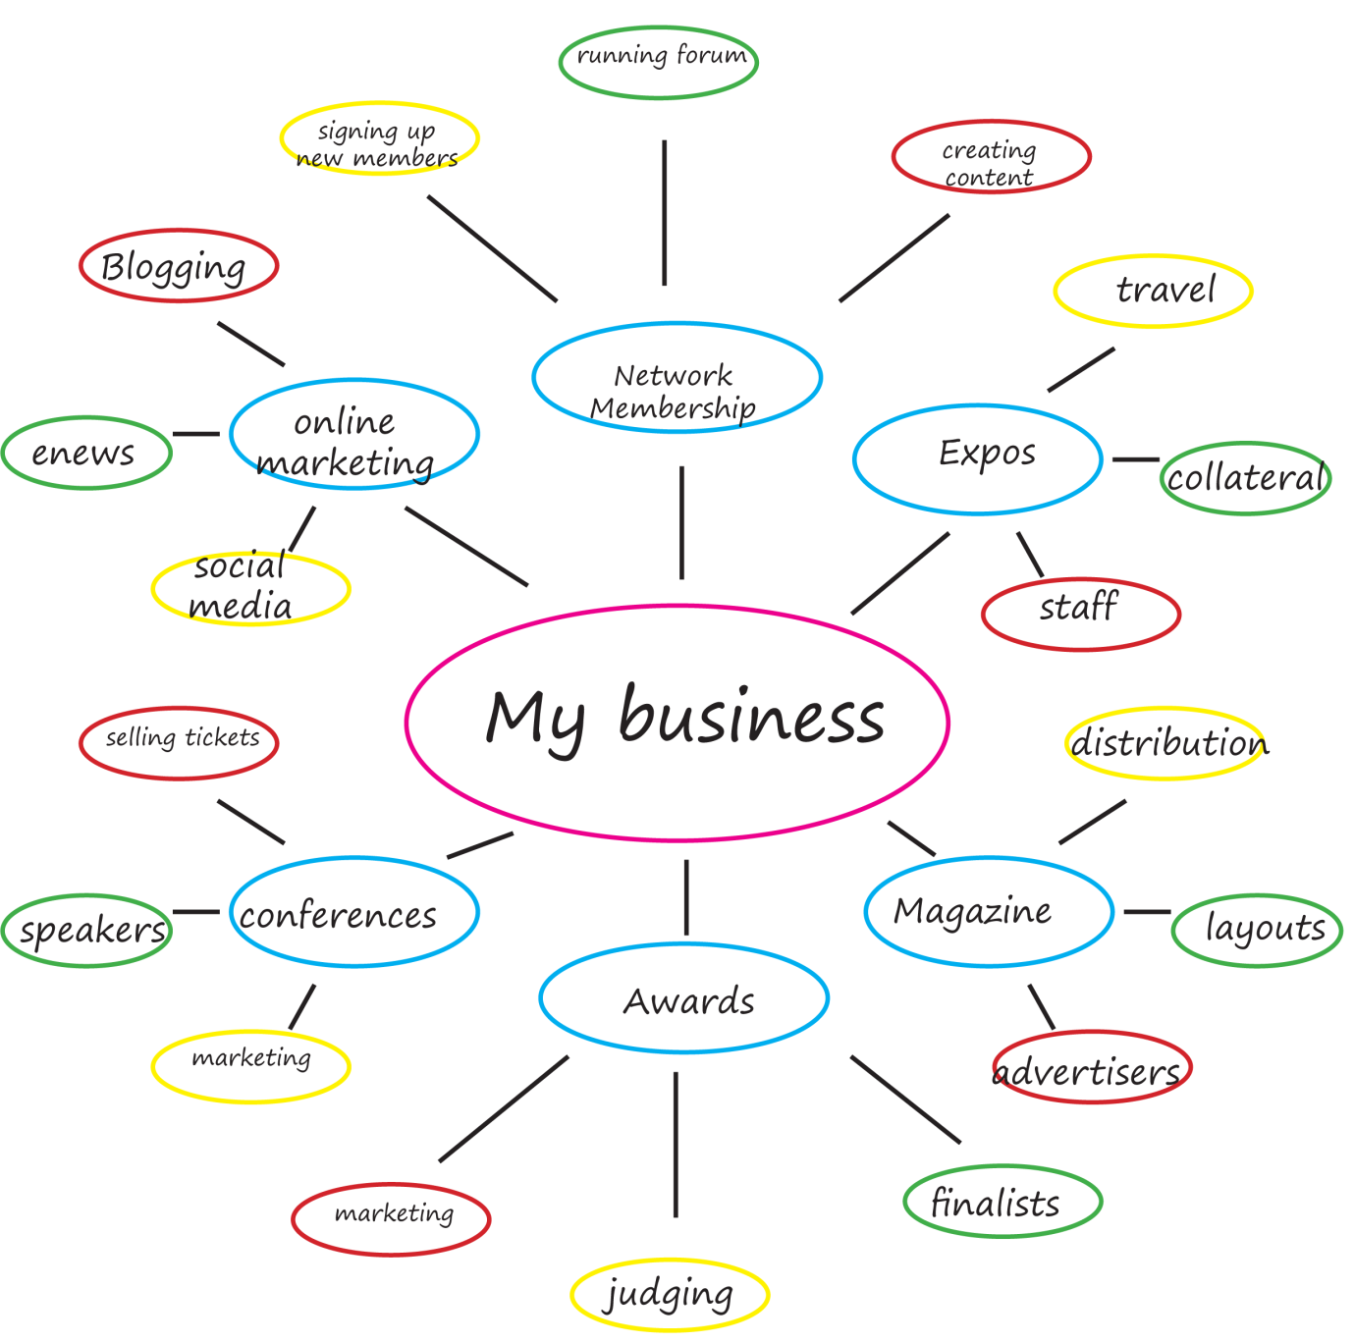

Step 2: Cross it off or keep
Stop right now, shelve it, delegate, do what you love!
Time to get creative, use coloured pens to:
- Cross out everything you want to stop doing*. Your intuition will help you here, but also think about the return on investment. Use Susan’s formula for the triple bottom line. For each one ask ‘Does this bring me: Joy? Purpose? Profit?’ and if the answer is NO cross it out. (*Obviously there are some things you can’t cross out like paying GST and doing your BAS so keep those.)

- Circle everything you can SHELVE or stop doing for now but bring back later if you want to – again use your intuition to guide you and the triple bottom line question.

- Highlight everything you want to keep – Check in with your intuition before highlighting each one – does this bring me joy? Purpose? Profit? The answer MUST be a resounding YES to keep it.
Step 3: Make a plan
Create a plan to focus on allowing you time to do what you love:
1. List the business tasks that you can delegate or outsource (HINT: these are normally things you CAN do but don’t LOVE to do, like admin, bookkeeping, spreadsheets etc but can be anything you’d like help with)
2. Create simple systems for each of these tasks
Break down the task into all of the steps involved, be as clear and detailed as you can so that anyone could come into your business and follow the system to know what to do. Here’s an example
MAKING COFFEE
- Fill kettle with water and turn on
- Open cupboard above sink and select a mug
- Put 1 tsp of coffee and 1 tsp of sugar into mug
- When kettle has boiled pour hot water into the mug
- Add milk and stir
- Serve
3. If you’re ready to outsource or delegate some of these tasks give it a go. Find a VA or contractor. If you’ve never used a VA and would like to try one we have a couple in the Facebook group so put a post up asking for help
4. You should now be left with the tasks that bring you the most joy! List the top 3 things you’re going to focus on
REFLECTION:
How did you find this activity? Did you use the triple bottom line formula to help guide you? Were you able to reduce or streamline the things you’re doing in your business? Any unexpected outcomes?

PART B
OPTION 2: YOUR DREAM DAY
1. Designing your life according to you.
Take a mini retreat – go to the beach, your backyard, your favourite café, the park or a quiet room in your house.
Think about how you want your life to look.
What does your dream life look like, get clear on this. When do you work? What is your house like? How is your health and fitness? How do you spend time doing things with friends and family?
Now I want you to imagine your dream day in exquisite detail.
You wake up fully rested from a good night’s sleep – what does your bedroom look like? What do your sheets and pillows feel like? Are they 1000 thread count Egyptian cotton or are they organic bamboo? How do you feel when you get up?
Now what do you do? The first 45 minutes of your day sets the tone for how your whole day will go. So how are you spending this time on your ‘dream day’? Exercise? Breakfast? Shower? Make lunches? Yoga? Meditation? Journalling?
Think about the details – what do you have for breakfast on your ‘dream’ day? And why? Because it’s delicious? Because it’s healthy? Get clear on these details
Do you go for a walk? To the gym? Do yoga? Play music and dance around the kitchen? Think about what would bring joy to your mornings and help you to start the day right.
Is it time for a shower after this? What happens in the shower? Are you using expensive creamy organic body wash? Do you have a large and fluffy plush white towel or a bathrobe? Is your bathroom clean? The small details here are the clues to changing your life.
Then what happens? Do you drive children to school? What do you listen to in the car? Do you talk with your kids? What kind of things would you talk about on your ‘dream day’? What would make this experience more joyful instead of ordinary?
Let’s think about working on your business. When does this happen?
Where are you working? What environment have you created in this future ‘dream’ time to help the ideas and creativity to flow? Are their flowers? Candles? Music? Art? Does it feel like a sanctuary? What could you bring to this space to give you joy?
What ‘kind’ of work are you doing in your dream day? How is your work bringing you joy?
What do you eat for lunch? It’s not a hastily made sandwich on day old bread, so what is it? Something nourishing? Something made with fresh ingredients? Where do you eat it? Instead of standing at the kitchen counter (which has been proved to increase stress) think of somewhere relaxing that would bring you joy, this is your opportunity to rest and recover, what could you do to bring joy to the experience of lunchtime in your dream day. Get clear on these details.
What happens when your children come home from school or your partner/husband comes home from work? Do you go to the park together? Have afternoon tea together? Do homework together? Go jogging? Make dinner together? What does this afternoon/evening time look like and feel like in your dream day? What do you have for dinner? And why?
How about after dinner? How do you wind down? How do you connect with the people around you? What do you do that brings you joy at the end of the day?
What does your bedtime ritual look like on your dream day? Do you have beautiful pyjamas? Do you have a bubble bath? Read a novel? Write in a gratitude journal? This is your ‘dream’ day so picture how bedtime would look if you could create a relaxing and luxurious experience for yourself.
Get the idea? Make it your own and think about what you would do on your ‘dream’ day to bring more joy to your life in the ordinary moments.
There are no right or wrong answers here and your dream day will look completely different to my dream day! Which is so exciting because this is what designing your life according to you is all about!

FILL IN THE EXQUISITE DETAILS OF YOUR DREAM DAY
6:00am
7:00am
8:00am
9:00am
10:00am
11:00am
12:00pm
1:00pm
2:00pm
3:00pm
4:00pm
5:00pm
6:00pm
7:00pm
8:00pm
9:00pm
2. REFLECTION:
How is your ‘dream day’ different from your typical day? What changes can you make right now to bring your dream day closer to your reality? Are there things that will take a little longer to make happen (eg maybe you dreamt of swimming in the ocean every morning and you want to live closer to the beach)? Can you make a plan to make it happen for you? What would it take for you to be living your dream day every day?

3. Try out your dream day
a. Plan to live your dream day one day this week or next week and get as close to your vision as you can, right down to the tiniest details – you may have to go to the shops and buy a new fluffy bathrobe!
b. REFLECTION: What was it like? How did you feel? Is this something you could incorporate into your life every day? What would stop you from living your dream day every day? If you were to live your dream day every day do you think you would see changes down the track to your health, happiness or relationships? Any unexpected outcomes?

ASSESSMENT ACTIVITY CHECKLIST:
Student Name:
PART A |  | COMMENTS
1. Enough detail provided for each element indicated
2. Enough detail provided for each element indicated
PART B
2 OPTIONS

1: The business edit
2: Your dream day
Has the student completed the task correctly

PART B
Student has a good understanding of the concepts explained in the activity
Overall Comments:

Marked by:
Date:

